Marketplace Web Application Using API Development in Python with Flask-Restful and MongoEngine

Hamzah Abdullah Al-Shorman

**1.Introduction**

Markets have existed for as long as humans have engaged in trade. Market is a location where people regularly gather for the purchase and sale of goods. With a revolutionary of Internet and programming, marketplace has changed a lot over the years. Marketplace is an easy, convenient way to buy and sell items through an online website. Buyers can look through listings or search for items to find great things to buy. sellers can advertise their items, leaving the details of any sales such as a title, short description, price and a category for their item.

MySouq is a web application client for the marketplace which we are trying to build it by using an API Development in Python with Flask-Restful and MongoEngine.

The main objective of the proposed marketplace is to let user buys and sell their items through MySouq website.

**2.1 Marketplace Functionality**

There are three main types of members in the marketplace process with multi-attribute exchanges.  i.e., buyers, resellers and Administrators shown in Figure 1.

Figure 1. Marketplace processes

**3. Architecture**

The marketplace architecture defines a main repository where the items are stored and linked to the corresponding services and templates. This repository is always up-to-date, with the providers allowed to update or delete dynamically the created items. Sample architecture show in Figure 2.

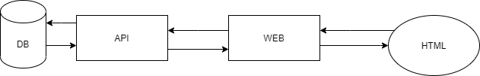

Figure 2

**4. Implementation**

**4.1 Buyers**

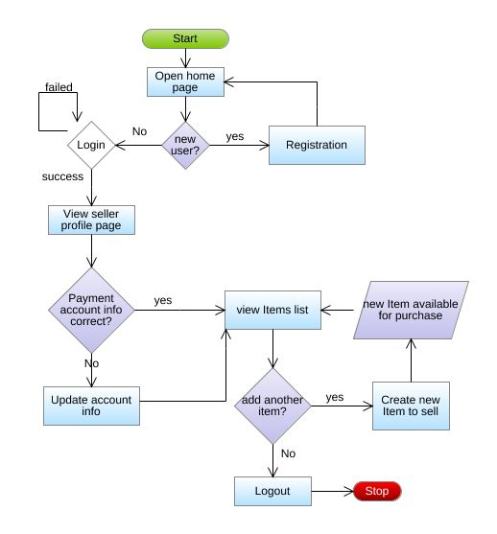

**4.2 Resellers**

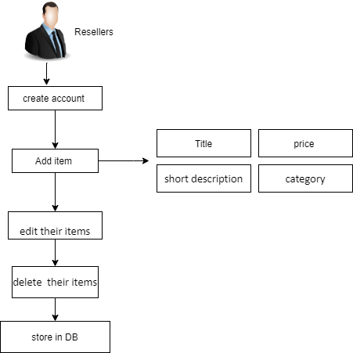

**5.Conclusions**

The proposed marketplace offers a one-stop support for Buyers and Sellers. We can still do better application if we enhance the search and authentication user functions. In addition, how to display the application on internet.